Potato outlook for reds

Source: The Grower (Becky Dumais)

June 25, 2018
22 Jun, 2018 By Becky Dumais 0 Comments
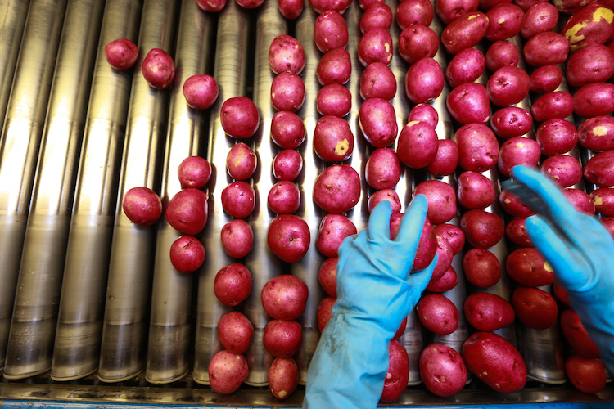
Findings from the recent United Potato Growers’ Crop Transition Conference have determined the appropriate shipments on several varieties of potatoes for U.S. and Canadian growers in order to move new crop as it comes on, without compromising any old crop that is still available. Red potatoes are the cause for most concern.

The conference, held in Minnesota on June 20 examined the 12-week period from July 14 to September 29 for russet, red, yellow and round white potatoes. According to Kevin MacIsaac, general manager of the United Potato Growers of Canada, determining how the market can receive the potatoes in a sustainable way and not put pressure on pricing from areas all coming on at once is critical. Each variety shows a different picture.

MacIsaac says yellow potatoes will take care of themselves in terms of the supply that’s available “mostly because the demand for yellow is very good and something stores and chains want to promote.” A late spring in areas such as Wisconsin will allow other areas --such as Kern County -- good movement before more volume comes in. In Canada, he says not much volume is anticipated before the week of August 4.

“The issue in the industry this year would be with red potatoes,” MacIsaac says. “There is definitely a lot of old crop left to move in the Red River Valley.”

Minnesota and North Dakota won’t likely get all of their old crop into the market this year and he says they may have to dump the potatoes before the new crop comes along.

“With all of the old crop left, packers will try to put as many of them into the market as they can and unfortunately that will move the supply curve into when the new crop is coming on. The first area that comes on every year is Big Lake in Minnesota and they’re concerned that there will still be pressure on the old crop.”

Canada’s production is expected in the week of August 18.

Shipments of russets will be on the lower side for the first six weeks; MacIsaac says it’s lower than the three-year average, as a result of Wisconsin’s late start and a large reduction in carryover in Idaho. Canada’s russets will be ready the last week of September. “We will be handed a market based on what has happened in those weeks before.”

Canada’s new crop of round white potatoes is anticipated the week of July 21, but “not significant volume until the weeks starting with August 11.”

Crops in Ontario and Quebec were planted earlier and though he says they’re not large volumes they’re early and doing very well.

“That will be an advantage to the red crop for other varieties not coming on as soon,” says MacIssaac.”The eastern part of Canada has been late in planting, particularly in Prince Edward Island. There are excellent crops in the west – Manitoba has one of their best-looking crops ever to date. Alberta is also doing well.”

Communication is essential between shipping areas to give everyone a big picture of the volume being supplied to the market during the crop transition to ensure growers are profitable.

“That’s really always our consistent goal every year,” says MacIsaac. “One of the ways to do that is to know what you grow, what you supply and how it meets with what the market actually needs.”

Author
Becky Dumais

